Colon Cancer and Liver Metastasis.
Stem: 70 year-old male was found to have biopsy proven descending colon adenocarcinoma while undergoing work-up for anemia. Staging work-up included CT CAP with IV and PO contrast demonstrated a single 4cm mass in the left lobe of the liver, no other distant metastatic disease identified, CEA elevated at 200.

What is your differential diagnosis?
- Malignant – metastatic disease, primary HCC, intrahepatic cholangiocarcinoma
- Benign - cyst, hemangioma, FNH, hepatic adenoma
What Workup would you do?
-Hepatic MRI with IV contrast –Likely with metastatic disease isolate to segment 3 and no additional metastatic foci, no extrahepatic disease and no portal lymphadenopathy. .
-IR guided biopsy – Consistent with colon adenocarcinoma as primary (No penalty if resident skips)
What is your management plan?
- Multidisciplinary tumor board discussion.
- Approaches (acceptable)
  - Neoadjuvant therapy FOLFX followed by synchronous or staged colectomy and liver resection.
  - Synchronous or staged colectomy with liver resection.
  - Colectomy followed by chemotherapy and staged resection of metastatic disease.
  - Liver resection followed by chemotherapy then colectomy.

What If widely metastatic and not amenable to resection?
- palliative chemo.

Scenario : 65 year old man who was diagnosed with sigmoid adenocarcinoma with small, diffuse liver metastases presents on diagnosis now presents on cycle 4/12 of FOLFOX + Avastin with abdominal pain, distention but no nausea or vomiting. How would you proceed?
- CT Abdomen / Pelvis : Dilated colon with transition point at sigmoid colon where known tumor malignancy is. Small bowel is not significantly dilated.
How would you manage?
- Endoscopic stenting.
- Diverting loop colostomy

Sarcoma.
Stem: A 55-year-old male presents to your office after being referred from his PCP for further valuation of an asymptomatic mass on his right inner thigh.
PMH: None. Family history is noncontributory.
PE: There is poorly defined right thigh mass, approximately 8 cm in diameter.
Labs: Not significant.

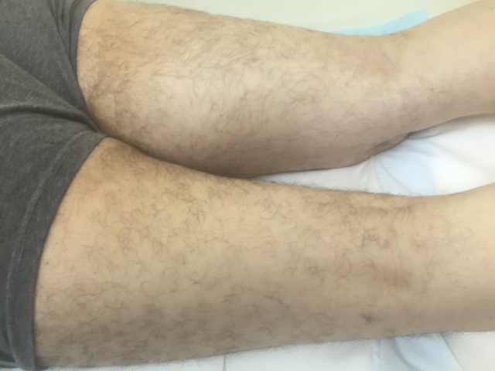
Describe how you would work up and manage this mass?
- Plain radiograph of the thigh: Soft tissue mass with fat density (Need to start with plain radiograph)
- MRI of the entire muscle compartment: Soft tissue mass, with low signal intensity on T1 and high signal intensity on T2
- Obtain core needle biopsy with multiple passes of 18g needle with site incorporated into possible resection margin → pathology: rhabdomyosarcoma
- Staging workup: CT of chest
What if the core needle biopsy came back as non-conclusive? - Obtain incisional biopsy - describe Technique. - Along the axis and don’t develop fascial planes.
Mass is high grade, how would you approach this mass from an operative standpoint?
- limb salvage.
- Excision outside the pseudocapsule.
- Radical resection with neurovascular structures and vascular reconstruction if needed.
When Is amputation indicated? - Inability to resect without amputation,
nonfunctional limb

Mass is Low grade, how would you approach this mass from an operative standpoint?
- marginal resection without sacrifice of neurovascular structures
- Excision outside the pseudocapsule

When to give postop radiation or post-op chemo?
a. High-grade tumor >5 cm
b. Stage III extremity sarcoma and pelvic/RP sarcoma.

Scenario : A 32-year-old man with a history of FAP presents with a 15-cm firm mass in the right axilla that restricts his range of motion. A CNB confirms a desmoid tumor. How will you manage this patient?

- Workup for familial syndromes: FAP, NF1, Li-Fraumeni
- Resection indicated in high-grade or symptomatic patients.
- Must council patient of >50% chance of recurrence even with R0 resection

What if the mass was low grade and asymptomatic? -
- Observe.
- Consider medical management with sulindac or other NSAIDs or tamoxifen.

What if this was a 32-year-old female and the mass was discovered during
pregnancy?
- Post-partum give sulindac or tamoxifen or observe.
- Most regress once hormonal stimulation removed.

Scenario 3: A 62-year-old man is seeing you in your office for the first time. He previously underwent exploratory laparotomy and resection of dedifferentiated liposarcoma 3 years ago and has now developed vague symptoms, including early satiety and abdominal bloating. He was lost to follow-up after his initial surgery. What would you recommend?

1. Complete imaging workup including CT Chest/Abd/Pelvis and MRI of the primary tumor bed
2. If recurrence and resectable then proceed with surgery. In general surgery is
indicated if R1 resection possible
3. If unresectable recurrence → chemotherapy (ifosfamide/doxorubicin)

Hepatic Abscess
Stem: You are called to the ED to see a 78 yo man who presents with 3 day history of fevers and chills, sweats and feeling poorly. He reports RUQ abdominal pain and some nausea but no emesis. He is otherwise healthy.
Vitals: T=99.9 degrees, BP=100/60, HR 110, and RR of 20.
Physical exam : Tender to palpation in the right upper quadrant without guarding or peritoneal signs.
Labs: WBC of 18K, LFTs slightly elevated, otherwise rest of labs normal.
PMH/PSH: Diverticulitis. Colonoscopy 1 year ago with diverticulosis

What Studies you would like to obtain to help you narrow the differential diagnosis?
- RUQ US: 7 cm fluid mass in the rightl lobe of the liver
- CT Abd/Pelvis : 7 cm fluid, with hyperenhancing rim and few air bubbles within it.
Based on these findings what is your differential diagnosis?
- Pyogenic liver abscess.
- Amoebic liver abscess.
- Simple cyst.
How would you manage it?
- IV access: Fluid resuscitation.
- Broad spectrum Abx to cover GI Flora.
- Look for primary source if suspecting pyogenic abscess.
- Serologic testing if concerned about amoebic abscess
- IR drainage.

Scenario 1: CT showed 3cm abscess not easily accessible by IR?
- long term antibiotics alone, in a stable patient may be reasonable. If gets worse, may need OR instead of IR.
Scenario 2: Patient presents in shock, hemodynamically stabilizes with resuscitation and able to proceed to CT. Findings included Intraperitoneal rupture/peritonitis? IR not available immediately and patient becomes hypotensive again?
- Patient should proceed to OR for operative debridement/drainage.
- Laparoscopic approach is preferred over open approach.
- Intraoperative US should be done to confirm complete drainage and not to miss another abscess).
Scenario 3: Patient presents with 5cm liver abscess and cholecystitis, confirmed by HIDA; how would you proceed?
1. If frail, IR perc chole tube and IR drainage of abscess with IV abx reasonable.
2. If not frail, proceed to OR for lap chole and drainage of abscess; IV abx.
Scenario 4: Same patient – serologic testing is positive amebic abscess. How would you treat him?
- IV metronidazole -- very high efficacy.
- Aspiration: reserve for very large abscess (if doesn’t get better with abx fast, etc).

